Should there be government intervention in the market in the case of the environment?

If so, what are some possible policy options and how would they resolve the issue?

Yes, there should be government intervention in the case of the environment, to address market failures due to externalities. I will first explore the general justification for government intervention in markets, then demonstrate that the necessary conditions are met in the case of the environment, and finally suggest policy options for such intervention.

Externalities exist when the actions of an agent affect other agents outside of the market mechanism. Without intervention in markets, these externalities are likely to lead to Pareto-inefficient outcomes – that is, the market may settle at an equilibrium where some agents could be made better off without making any agents worse off. Pareto inefficiency is an undesirable state of affairs to be in because it leaves some welfare on the table: there are possible improvements to be made that nobody would object to, yet (due to each agent acting only in their private interest) they are unrealised. If there exist government policies which can change the incentive landscape for self-interested agents so that a Pareto-optimal outcome is arrived at, then we should support such intervention, given the premiss that the government’s purpose is to deliver the greatest aggregate welfare for its citizens over the long term.

*Diagram below: suppose the blue line marks the current maximum output in a system of two agents. We can say that the allocation at point Y is a Pareto improvement on point X, as indeed is any allocation within the black shaded region, as it makes some agents better off without making any worse off. Point Y is not Pareto-optimal, though, as it is itself Pareto-dominated by other points (including those on the highlighted portion of the blue line, which are Pareto optimal).*

Environmental goods involve many externalities, each of which would justify government intervention to bring about an efficient outcome. I will focus on three areas which highlight slightly different features of market failure in the case of the environment, but which can all be addressed with similar policies: biodiversity, greenhouse gas emissions, and fish stocks.

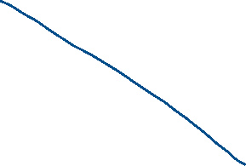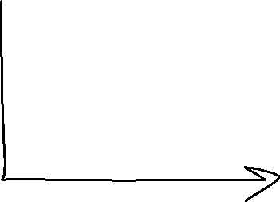

Biodiversity is non-rivalrous and non-excludable, meaning it is a public good. Everyone is able to enjoy the benefits of biodiversity without impinging on another’s ability to do so, and you cannot prevent people from enjoying these benefits. Public goods are typically under-supplied by markets, leading to inefficiency. To understand why, first note if an agent paying to increase supply of a public good creates a positive externality, then private benefit from each unit of the good purchased is less than the public benefit. As shown on the diagram below, agents will only purchase the public good up to the quantity where private benefit = marginal cost (i.e. q*), whereas it would be best for welfare is the good is supplied up to q~, since that is the point at which the social cost is equal to social benefit. If the agents could get together and offer their aggregate WTP (i.e. the social benefit) as the upper bound on price, the equilibrium would move to q~ from q*. This would eliminate the highlighted deadweight loss (forgone surplus due to potential transactions where WTP > WTA not happening) and result in every agent having at least as much welfare as before: a Pareto improvement.



**Social benefit**

**Private benefit**

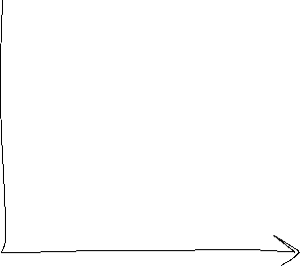

Greenhouse gas emissions are a similar problem, except they involve negative externalities: the actions of each agent in producing CO2 will harm other agents outside of the market mechanism. If we look at the problem from the other direction, in terms of the supply of clean air (via agents paying for emissions-reducing measures) then we would arrive at the same diagram as above: the social benefit of a marginally more CO2-free atmosphere is greater than the private benefit, and so emissions abatement is undersupplied.

Fish stocks are not a public good, since they are rivalrous: one agent benefitting from them does prevent another from doing so. However, they are non-excludable, which means they are a shared resource, and liable to inefficient outcomes due to the tragedy of the commons. Each agent has an incentive to send out a boat to fish so long as the private benefit of doing so is greater than the private cost. But, since there are negative externalities (my sending out a boat to fish harms you outside of a market mechanism, since I’ll be catching some of the fish you would’ve liked to), the social cost is greater than the private cost, and so more boats will be sent out than is Pareto-optimal.

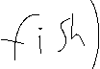

DWL due to transactions happening where aggregate WTP < WTA i.e. oversupply

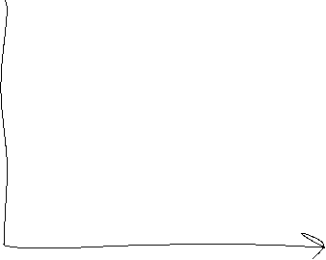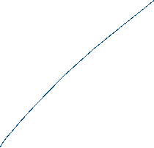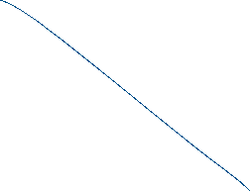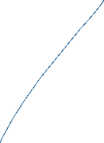

Governments can address these issues by introducing additional market mechanisms or regulations. The “Coase” solution of government assigning property rights over externalities, making public goods and common resources excludable, is one potential policy approach. This would involve the government issuing tradable permits to pollute or fish (and in the case of biodiversity, obligations to supply it) to some arbitrary agents, and then allowing all individuals to buy or sell these permits (obligations) as they wanted to. The permits would then end up owned by those who value (disvalue) them the most (least), and the equilibrium would be efficient. If permits are given away to one agent for free, the same equilibrium would result, since they would still choose to sell the permits to anybody with a higher valuation than their own, but the surplus would be captured by whichever agent was given the permits, which some may view as inequitable. Governments could address this by auctioning the permits instead. This may be more desirable from an inequality viewpoint, as it means the surplus created by the measure accrues to the state, which can use it for redistribution as desired, like how tax revenues do in the Pigouvian approach to follow. However, this market-based approach may itself fail: if the transaction costs of trading permits are high, then not all trades where WTP > WTA will occur, and the efficient equilibrium will not necessarily be reached.

An alternative approach, though one which yields exactly the same equilibrium if the government has perfect information, would be to place a Pigouvian tax on the production of goods with negative externalities (or symmetrically a subsidy on those with positive externalities), so that private incentives are such that the efficient amount of that good will be supplied. *See diagram below.* If the government knows what the efficient quantity q~ would be, then they can levy a per-unit tax T so that the new private cost of the good S’ will be equal to private benefit, i.e. demand, at that quantity q~ . This ensures that the efficient amount is supplied. There is, however, a political downside to this approach: taxes are very visible and unpopular signs of government intervention, and subsidies will have to come out of the government’s budget.



One final, though most likely ineffective, approach is to set quotas around the permitted quantity of goods with externalities. Governments could require that specific agents produce no more than a certain amount of fish or CO2 emissions (or no less than a certain amount of biodiversity). By setting quotas for all agents, government would be able to reach the desired level of, say, CO2 emissions. Governments could also revise the quota allocations over time, if wanted. However, this outcome would likely be socially costlier than in the efficient case: it is likely that agents will value the permissions differently, but if quotas aren’t transferrable, mutually-beneficial & welfare-enhancing trades will not happen. Furthermore, the method used to allocate quotas, such as by historic emissions or fishing levels, may create socially undesirable incentives for agents to use their quotas to the maximum (and fail to invest in alternative, less negative externality-producing technologies), if they are otherwise at risk of having their quota reduced at the next revision. Quotas may be appealing to those who believe it is unjust for some agents to do “less than their share” in addressing collective action problems, though. Since WTP encompasses ability to pay, richer agents having the chance to pollute more simply because they can pay others to pollute less may be seen as unfair, and proponents of quotas might be comfortable accepting some level of inefficiency in exchange for what they believe to be a fairer outcome.

In conclusion, yes, there should be government intervention in the case of the environmental market failures due to externalities. Tradable permits or Pigouvian taxes could both resolve the issue, depending on assumptions made around transaction costs and information available to the government, and could have different distributional effects depending on implementation. Quotas would in all likelihood not lead to an entirely efficient outcome, but can go some way to addressing the issue whilst also being more in line with some normative ideals of justice and fairness.

This is a good essay. It is well-structured, and your writing is very clear and engaging.

Some thoughts:

* govt intervention may take us from a Pareto inefficient allocation Y to a Pareto efficient X. But it may not be the case that X Pareto dominates Y. In other words, restoring efficiency may generate some winners and losers. (This is related, I think, to your first comment)
* You do a good job of starting with an explanation of what yardstick you’ll be using to determine whether govt should intervene; i.e. externalities -> loss of surplus -> loss of surplus can be corrected via intervention. Where I think the essay could be stronger is in the choice of things you focus on. You went “wide”: biodiversity, fish stocks, emissions. You nicely brought out the differences between them but, because there were many topics, you couldn’t dig that deep into each of them. An alternative might be to select one and push the analysis further for that one. You should still mention the others by saying that “environment” is very broad and that there are some differences in how we would tackle the problem of biodiversity vs fish stocks (say), but that for the purpose of this essay, you’ll focus on emissions. [The question gives you the latitude to do that.] Showing that you are aware of the possible differences in approach depending on whether “environment” means biodiversity or fish stocks or whatever, is a good thing. But, by also focusing your essay on one particular aspect of environmental policy, you can also showcase not just breadth but depth too. So what am I thinking of when I say “depth”? Well… much of what you said in the essay can be applied to any externalities problem (e.g. environment, health/smoking, etc). I think some discussion of policies that specifically apply to the environmental problem that you will have chosen would be good.
* I really like the manner in which you analyse not only the efficiency but also the equity of your policies. This is something you should keep doing in other essays too.